Initially Random Data

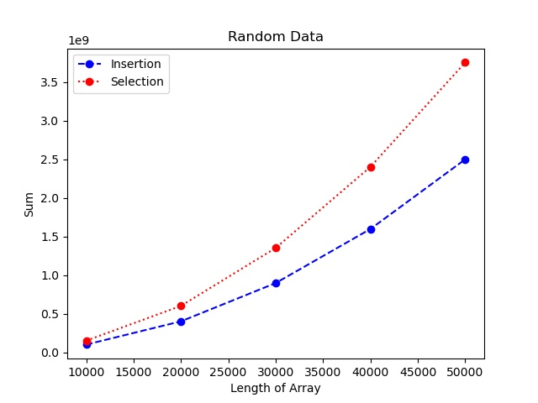

Insertion sort takes fewer steps than selection since through each run, of the insertion sort much of the array trends to be more in order than the last run, since there are comparisons being made between all the consecutive elements during each run, to speed up the process of sorting the list, causing less work later, when the list is closer to sorted. Meanwhile, the selection sort is making comparisons between the elements and only being able to switch the spots between elements once per run, which makes the algorithm much less efficient than insertion sort for the randomly arranged data.